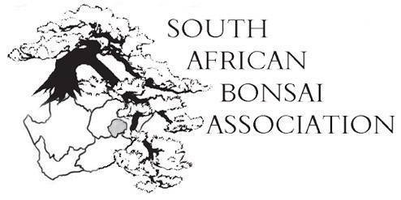16 October 2017

Dear SABA-members,
In terms of the constitution notice is hereby given of the Annual General meeting to be held on 17 November 2017 at 1715 at the Diaz club, Third avenue, Newton Park, Port Elizabeth at our national convention.
We’ve had a very good number of registrations for the convention and for those who have not done so yet please do so speedily. It is important that as many members as possible attend as we have a lot to discuss and decide on. Please also check if your club has paid its annual fees as only those who have paid have voting rights. If a chairman of a club cannot attend notice must be given who has a proxy vote for that club. Please also find attached the financial statement approved by the auditors.
I am looking forward to seeing you all there and to renew old bonsai friendships. Robbie and his team are putting in the hard yards and we appreciate all that is done. Please prod all your members to come and join the bonsai fraternity and see and hear about the exciting things happening in different regions.
Agenda 2017
- Presidents report and election of the new Exco.
- Report from Jonathan Cain, president of the African Bonsai Association.
- Tenders for the next convention and the one in 2019. At the last AGM it was decided that we rotate the yearly convention between regions. Please discuss this beforehand in your region so that we have a clear planning strategy.
- Lifelong achievement awards. We’ve had four nominations from different regions. The Exco will decide on who gets awarded and the results will be announced at the convention. Please ensure that your nominee is present to accept if he/she is awarded. If the nominee is not able to attend the club needs to nominate someone to accept on their behalf.
- The SABA logo needs modernising and an update. A motion was forwarded that we take a decision on this at the convention. (KwaZulu-Natal).
- A motion was put forward that the Exco be changed to ensure continuity with positions for a President, past president and President Elect. (KwaZulu-Natal).
- Financials to be discussed by treasurer and for the AGM to agree on.
- A motion was received that people with bonsai business interests be excluded from the Exco. AGM to vote on motion.
- The SABA photo competition to be discussed as well as the way forward and ways to improve.
- The SABA calendar will be introduced by Earl Jeffreys and be for sale (cash only). Discussion on making this a yearly institution.
- A motion was received that we change the format of the New Talent competition to allow bigger regions to send more entrants to the convention. (Gauteng).

.
And that is all for now. Any other motions for discussion should be send to me at least two weeks before the convention with a proper motivation.
I am looking forward to see you all in Port Elizabeth. Let’s make this a cracker for the good of bonsai.
Regards,
Willem Pretorius
President.

