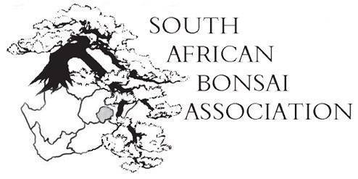
SABA newsletter (29 September 2014)
Dear members,
The convention in George went swimmingly and a great time was had by all.
Eighty members attended the conference on Saturday and luck number 77 won a vintage bottle of Meerlust that I had my eyes on. A hundred people turned up for the spit braai on Saturday night and though some were carrying injuries from the previous night’s tenpin bowling no serious complaints were received.

Attached to this please find the President’s report as well as the minutes for the AGM that was well attended. Please go through it and notify us of all corrections before the end of October. It makes no sense to wait a year to approve the minutes at the next AGM.

Katriver Kai did a splendid job with all the arrangements and put up a beautiful display of trees as well as a funky New World Bonsai show that tested the limits of creativity. All in all the enthusiasm was catchy and let to late night discussions on soil mixes, pruning, designing and the overall state of bonsai in the world. After this convention we can say the spirit of bonsai is alive and well in South Africa.

Lifetime achievement certificates were awarded to Charles Ceronio, Louis Nel (postuum), Theuns Roos (who sadly passed away in the week of the convention), Rob Clausen (postuum); Rudi Adam and Gail Theron. Congratulations to them all and their families who supported them over the years.
The SABA Cup in the photographic competition for the best exotic tree was awarded to Tobie Kleynhans for his Pyracantha. Second prize went to Freddie Bisshoff for his cork bark elm and the third prize went to Carl Morrow for his Chinese maple. The judges were Jerry Meislik from America, Bernie O’Callagan and Don Stevensen (both Namibia).
The Tommy Flaxman trophy for the best indigenous tree was won by Toby Kleynhans for his ficus natalensis. The second prize went to Charles Ceronio for his Buddleja saligna and the third prize to Tobie Kleynhans for his portulacaria afra. The judges were the same as for the SABA Cup.
The Young Designer of the year was Wayne Viljoen of (Midway bonsai). In second place was Roelof du Preez (Border) and third was Phill Levitt (Oyama). Congratulations. The competition was tough and the result accepted by all.
In the Masters category Viky Petermann (Oyama) was triumphant. She was followed by Mack Boshoff (Kierieklapper Bonsai) and in third place Anthony Smith (Pretoria Bonsai).
Great work all of you. I loved the interaction and bantering between the contestants.
Until the next time.
May your trees grow with you.
Willem Pretorius.
President.

