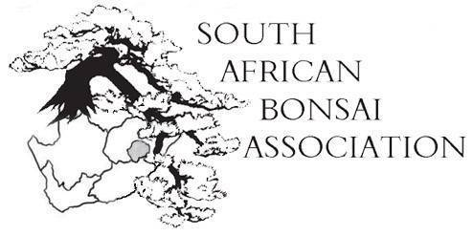

21 November 2016.
Dear SABA members,
For the first time that I can remember all the decisions taken at the AGM were unanimous. Could it be that we have a new growing consensus about bonsai in South Africa and where we are going?
A big thank you to all who made the effort to join us at the SABA national convention in Bloemfontein from 18 to 20 November. And an even bigger thank you to Vian Herbst and his club who put in a lot of effort and (thankfully) did not turn up in orange shirts.
The event was well organised, everything went smoothly and it seemed as if everyone was happy. The 75 members registered for lunch on Saturday enjoyed the company so much they were reluctant to get back to the hall for the demonstrations! And it was so funny to hear about all the guys who said they were going to dig only one tree early on Sunday before it got too hot bragging about their finds long after lunch….
Thank you to everyone who bought the SABA calendar to help us raise funds. We printed a 100 and they sold out. Those of you who were caught sleeping can still order some but we need to get proof of payment by month’s end to print and post them. We will consider printing more in the new year if the demand is there but the deadline of 30 November is the final one for this year. Because of postage it will now cost R110 per calendar.
As prescribed I attach the president’s report and the minutes of the AGM. Any alterations or additions to the minutes must be received within 30 days where after the minutes will be considered approved. This way we don’t have to go through the schlep at next year’s meeting.
The detail of what happened are in the minutes but as a quick guide to what the AGM decided:
- To award Dot Henegan (Bloemfontein), Berrie Ras (Waterberg) and Derry Ralph (Shibui) for Lifelong Achievement to South African Bonsai.
- Merit awards for trees were given to Charl Botes, Kathy Steyn, Vian Herbst and Juan Duvenhage (innovation).
- Caroll Hermann was voted onto the Exco in the position vacated by Anthony Smith and will be responsible for running the SABA website from now on.
- That the new constitution (with minor changes in the formulation of some clauses) is accepted as the constitution of the South African Bonsai Association. Thereby nominations for representatives from every region must be chosen and Exco informed before end of January 2017.
- That the membership fees will increase next year from R30 per member to R40 per member of a club as there has been no increase for the last number of years.
- The SABA Photographic awards went to Hannes Fritz (exotic) and Jonathan Cain (indigenous). Tobie Kleynhans was the runner up in both categories.
In future the judging panel will consist of representatives from every region and therefore the soonest the different regions select someone the new format can get going.
- The following motion was agreed on by everyone:
In order for a free, fair and democratic decision by SABA on who will be chosen to represent South-Africa at future international bonsai conferences we are invited to it is proposed that:
a) Details of the invitation are published as soon as it is received with a call for CV’s of nominees and a properly motivated recommendation by the club/region.
b) The nominations are published in a newsletter and all registered clubs get one vote for their candidate and the majority vote wins.
- Jonathan Cain, president of the African Bonsai Association, was recommended for the sterling work he is doing to promote South Africa overseas. He is also tasked to explore the possibilities of South Africa hosting the World Bonsai Conference in 2025.
- The winners of the New Talent Competition were (1) Stefann Pretorius; (2) Brett Simon (Oyama) and (3) Bradley Patterson (Kengai).

A big thank you to everyone for the support and many kind words. Let’s do it for the good of bonsai.

Willem Pretorius.
President.

