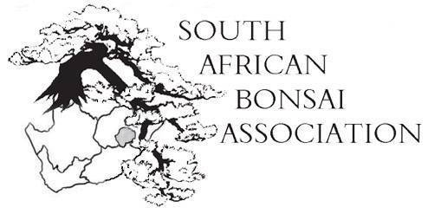
18 August 2014

SABA newsletter

Dear members,

The countdown to the SABA mini-convention in George hosted by Katrivier Kai has started. If you haven’t registered yet do so now as it promises to be a great event with lots of interesting events planned.
The annual general meeting of SABA will be held on Friday 26 September 2014 from 17h30 to 18h30 in the conference hall at Mountview, George.
Please try and be there as we have important matters to discuss. Thanks to all the clubs who paid their subs on time. Remember only clubs who paid their subs are permitted to vote at the AGM.
On the agenda is the president’s report of the last 12 months, the report by the treasurer on financial matters and the auditor’s statement and the new budget.
If there is any other matter or motion to be discussed please inform us beforehand for inclusion on the agenda.

Other matters:

- Formulate a policy for clubs to tender for hosting future SABA conventions and ensuring that it is fairly distributed amongst the regions. SABA’s contribution to the hosting club must also be discussed.
- Formulate a policy to nominate office bearers in future when consultants and representatives of SABA are appointed.
- We will also have a report back from the Africa Bonsai Association on matters related to SABA.
- The steering committee for the 4th Africa Bonsai Convention next year in Stellenbosch will give a wrap of how the organising is going.
- The awarding of the SABA lifetime achievement awards.
- The SABA and Tommy Flaxman trophies for the photographic competitions will take place.
- Discuss and approve the yearly ABA membership fee of USD 100-00 to WBFF
- General.

SABA dig:

The SABA dig hosted by Robbie de Witt and the EP Bonsai Society on 26 July went down very well, with lots of new friends, great material dug and discussions late into the night with some refreshments.
I’ve just received news from other diggers that the first buds are popping out from their material. It is such an exciting time with the energy of spring and so much to look forward to.
Robbie was an excellent host and indicated that he would love to make this a yearly event. I think it is a great idea and the fact that people like Org came from as far as Pretoria an indication of the quality of trees that can be found. Robbie has excellent windswept trees that he collected over the last few years and it was very informative to see how they have developed.
The fact that members of his club gave up their own digging chance to help beginners find good material is the spirit we would like to see. Thanks again to everyone who made it such a great weekend.

Orchids and bonsai:

The 21st World Orchid Conference takes place at the Sandton Convention Centre from 10-14 September 2014 and there will be some great bonsai and ikebana on display.
This is the Olympics of orchids and South Africa’s greatest flower and plant extravaganza. More than 440 orchid enthusiasts from around the world have registered for the conference. National Orchid Displays from 11 counties and 17 South African entities will take part.
It will showcase another 12 National Displays. The National Biodiversity Institute, National Cycad Society , Bonsai of South Africa, Wild Orchids from South Africa, National Carnivorous, Strelitzia, Aloe and Ikebana displays.
Something not to be missed! For more information contact Maggie Frohlich at 082 8157186 / 012 7724351.
Other matters:
We enclose a leaflet for a bonsai weekend in the Eastern Cape that looks like a lot of fun. Please feel free to send information on planned events so we can distribute it to members.
Thanks so much for all the feedback you send on what is happening at your club. Please keep the letters, advice and criticism coming. Bonsai in South Africa is alive and well and together we will grow.
See you all in George.
Regards,
Willem Pretorius;
SABA: President.

