2 September 2015.
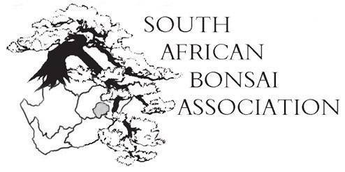

Dear SABA-member,
Things are hotting up and we are on track for what promises to be a remarkable convention in October in Stellenbosch. We had a fruitful SABA Exco meeting last night by Skype and a lot of exciting projects were discussed. I also attach a newsletter from the steering committee for the convention. Please distribute it to all your members and encourage them to attend.
A big thank you to all the clubs who paid their membership fees promptly and on time. And also a big welcome to the new clubs and individuals that have joined. We look forward to hear from you and hope you will help in promoting bonsai in your community.
To those of you who are lagging behind and have not paid yet, remember that we need your support to grow bonsai in South Africa.
The fees are R30 per clubmember and the bank details are:
BANK : F N B
ACCOUNT NAME : South African Bonsai Association ( SABA )
ACCOUNT NO : 62444063078
BRANCH : Pavillion Durban
BRANCH CODE : 224326.
Please send confirmation of your payment to willempret@mweb.co.za so I can keep track of the numbers.

AGM in October

In terms of the constitution notice is also hereby given of the AGM to be held on 22 October 2015 in the Stellenbosch City Hall from 1800 to 1900.
Any club who wishes to propose specific points for the agenda should do so not later than two weeks before the AGM.
At the moment we have the following points on the agenda to be discussed.
- The president’s report.
- Financial and auditor’s report.
- The election of a new Exco as the two year term of the current Exco comes to an end. There is a proposal that we change the current voting system so that each region votes for a representative on the Exco to make it more of a federal system where regions are better represented. From that group a president, vice president, treasurer, editor and secretary is chosen. This proposal will be discussed at the AGM before we commence with the election of officials.
- The minutes of the previous AGM in George were circulated and accepted by all so therefore there is no need to revisit this unless there are a compelling reasons to do so.
- The budget for 2016 will be discussed at the meeting as the new Exco has to be involved with it.
- One application to host the convention in 2016 has been received and will be put to the vote at the AGM.
- Clubs who cannot make it to the convention are reminded that they must indicate before the meeting who will receive their proxy votes on all matters.

Lifetime achievement awards
We have received five nominations for the Lifelong Achievement Awards. Thanks to all the clubs who send in their nominations. At the Exco meeting last night it was decided that three will be awarded this year and the others considered for the next year by the new Exco.
New Talent
We received eight entries for the New Talent competition to be held at the convention on 23 October from 1400 in the city hall of Stellenbosch.
So fa the entries are Gauteng (2); Southern Cape (2); Western Cape (2); Natal (2). We would like to see more entries from other regions as well.
We would like to encourage the other regions to join in. Come on Free State, Eastern Cape, Limpopo, Mpumalanga! Please contact Earl at earl@katrivierkai.co.za to book your places now.
This is something you will always cherish on your bonsai CV.

Trophies
We hereby ask all previous winners of SABA trophies to please bring them with to the convention. If you are not attending please arrange with other club members to bring them. All trophies, prizes and certificates will be handed out at a special cocktail hosted by the mayor of Stellenbosch on 23 Ocotber from 1800 in the city hall.
So that is the news for now.
I would like to hear from you. A big thank you to all the clubs who are keeping us informed about what is happening in their region.
Bonsai greetings to you all,
Willem Pretorius
President: SABA.

